**PARAMETERIZED BUILD**

A "parameterized build" in Jenkins refers to a build job where you can define variables (parameters) that users can input values for at the time of triggering the build, allowing for dynamic customization of the build process based on the provided parameters, such as environment settings, file paths, or specific configurations depending on the needs of the build.

**How to create a parameterized build in Jenkins:**

* **Go to your Jenkins job configuration:**

Navigate to the job you want to parameterize and open its configuration page.

* **Enable parameterization:**

Check the checkbox labeled "This project is parameterized".

* **Add parameters:**

Use the "Add parameter" dropdown to define the type of parameter you need (e.g., string, choice, boolean) and provide a name and description.

* **Use parameters in build steps:**

Within your build script, access the parameter values using environment variables (e.g., For Windows %PARAM_NAME%).

**Create new job using freestyle project:**

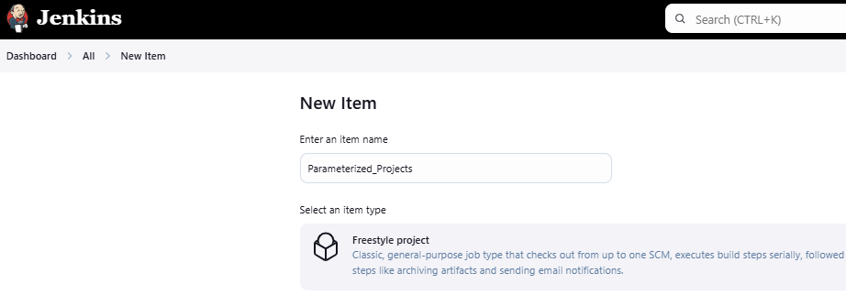

**Select the option “The project is parameterized”.**

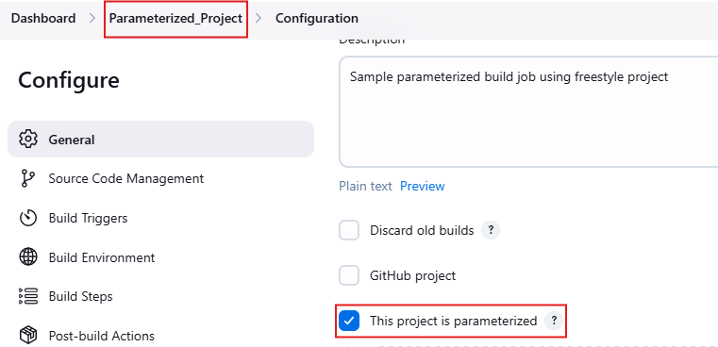

**Using Add parameter field, choose a parameters like below**

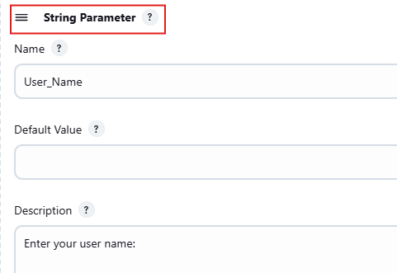

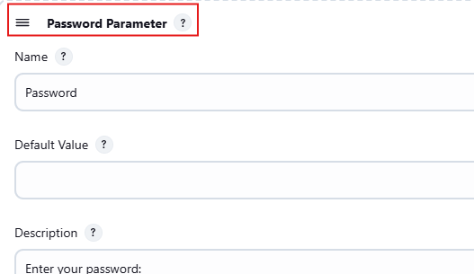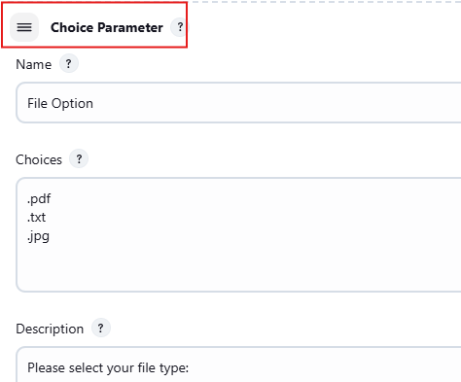

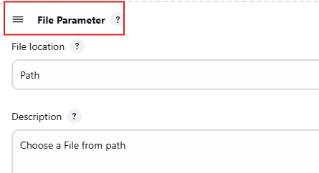

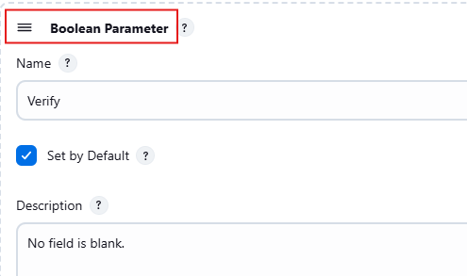

**Access the parameter values in Build Steps a below.**

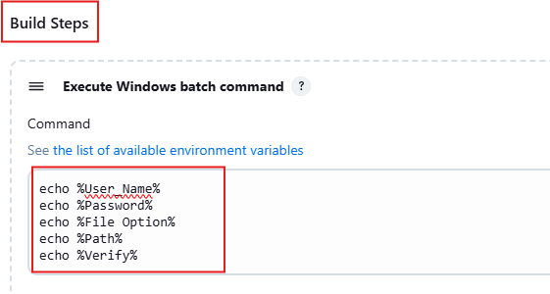

**For Email Notification use post-build Action and enter the recipient list.**

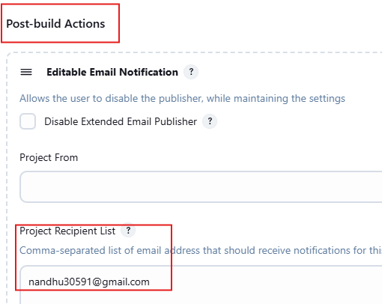

**Set a Cron Job to build automatically without manual intervention.**

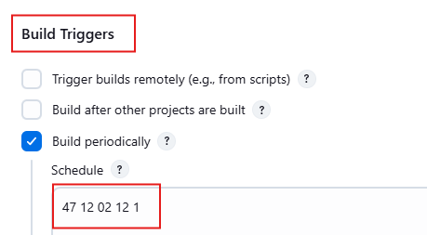

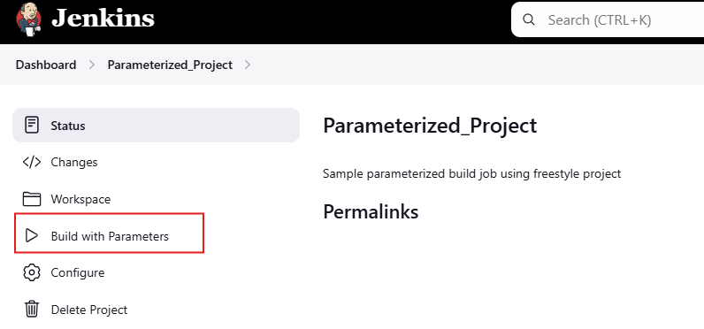

**Enter the required parameter details and cron job will build the job automatically.**

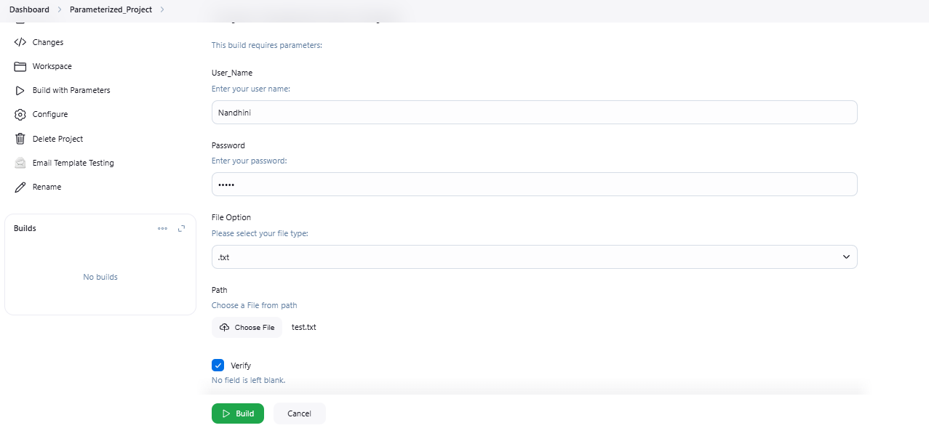

**Cron job builded a job successfully at schedule time:**

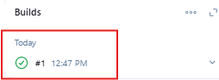

**Timer Output:**

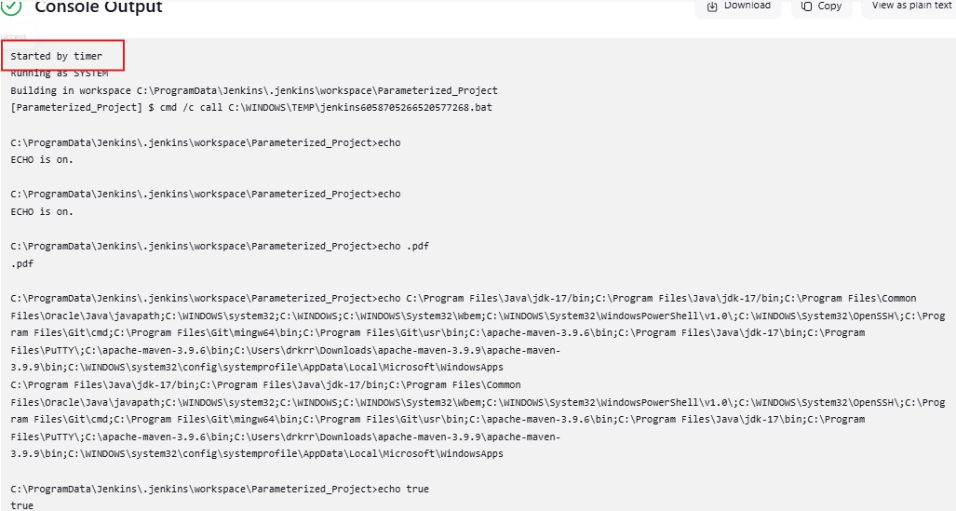

**Dashboard after build success:**

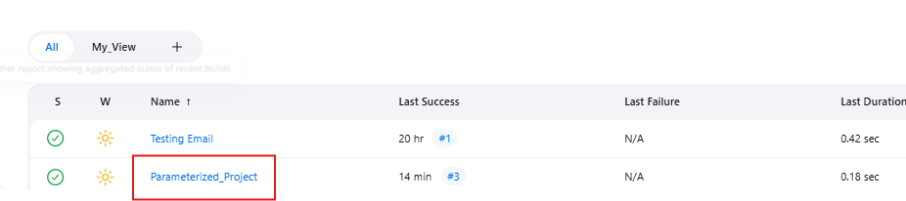

**Received Email Notification once the build got success:**

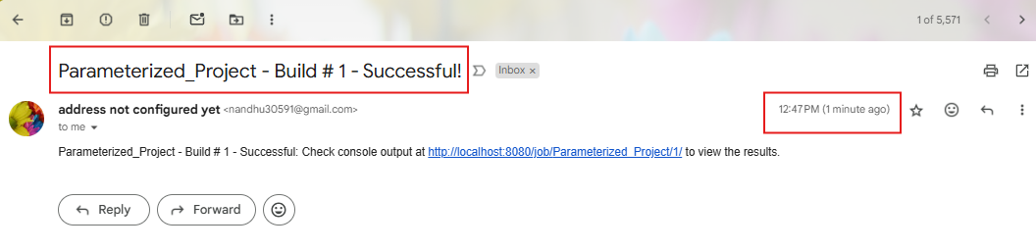

**Manual Build Output:**

